Guidelines for education institutions no.2

Career counselling for school students

Deliverable fact sheet
Document name |  | Guidelines for education institutions No 2:  Career counselling for school students
Responsible partner |  | Smart Continent
Authors |  | Egle Kalasnikovaite, Ieva Girdvainiene
Work package no. |  | WP3
Work package title |  | Management on Coordination of National HUBs
Dissemination level (please select one)
CO | Confidential, only for members of the consortium including the Commission Services
PU | Public |  | X
PP | Restricted to other programme participants, including the Commission Services
RE | Restricted to a group specified by the consortium including the Commission Services

Contents

The research 4
1. Career guidance in theory 4
2. Guidance practices in Baltic states 5
Guidance system in Estonia 5
Guidance system in Latvia 6
Guidance system in Lithuania 7
3. Analysis of the data gathered and the guideline – influences for the decision 7
3.1 The study on career guidance 8
3.2 The main criteria on deciding the study field – theory 8
3.3 The main criteria on deciding the study field – findings 9
3.4 The guideline 12

The research
The Baltic Hub conducted a study to identify the practical link between career counselling and how students choose higher education and post-graduate education, focusing on the areas of STEM, smart mobility and transport. Within the framework of this research, the analysis of the theoretical basis and legal framework, consultations with schools in the Baltic States and the analysis of the collected data took place. The aim of this work is to develop theoretical material that could be used in schools, career counselling and related institutions to encourage students not to be constrained by external factors in pursuing their career goals and to stimulate students' interest in STEM and smart mobility studies. The theoretical material consists of 3 subject oriented guidelines. In this document the subject of school student consultations and their type was set and discussed.

1. Career guidance in theory
Because of the importance of the school environment in the life of a student, it can seem that school experiences and imprint of a school environment have a mildly strong influence on a student when deciding his or her career preferences as well. In a 2013 study of S. A. Amoah, I. Kwofie and F. A. A. Kwofie “The School Counsellor and Students' Career Choice in High School: The Assessor's perspective in a Ghanaian Case“ , the impact of the school career counsellors was being analysed.
The authors have analysed qualitative and quantitative researches on the subject of whether and how the career counsellors play role in the students career preferences and decision. According to the results of their research, the impact of the career counsellors was defined as existent but had low significance. Authors say, this outcome might be impacted by the lack of resources of the counsellors, the absence of effective or efficient follow-up, etc. The authors of the article have recommended to apply frequent intervention programmes for students “in order for the to make well informed choices”.
Another analysis of Maria Eliophotou Menon on the students in Cyprus demonstrated that “career counsellors are of very little importance as sources of influence and guidance in the decision-making process preceding entry into higher education.” The authors have identified several aspects (mostly related to the workplace issues) that could influence such a minor impact of the career counsellors for the students regarding the career choice: the heavy workload and associated inability to advise effectively large numbers of students; the lack of clearly defined roles and responsibilities; their employment in more than one school unit; the lack of up-to-date information on career development choices and recent educational reforms; their limited communication and cooperation with external agents; and the lack of supporting mechanisms and appropriate infrastructure.

2. Guidance practices in Baltic states
In this chapter, the institutional and legal framework of career guidance and national practices will be presented.

Guidance system in Estonia
For some time now, lifelong vocational guidance has been practiced in Estonia, not limited to one age group, but promoting the development of the population's abilities according to their interests, hobbies and desires. During the development of these services, various service providers were responsible for their provision and implementation, but this is currently done by Career Services.
2020 A follow-up to the Estonian Lifelong Learning Strategy was prepared in 2021-2035. education strategy. The strategy sets out the main goals of education for the next 15 years. The overall goal of the strategy is to provide the Estonian population with knowledge, skills and attitudes that will prepare people to realize their potential in their personal, professional and social lives and to contribute to improving the quality of life in Estonia and global sustainable development.
Following the recognition by the Estonian government of the need to improve the availability and quality of career services, in 2018 The reform of service provision was launched in 2019. career counseling and career information services were launched. Responsibility for these areas fell on the public employment services under the Ministry of Social Affairs.
The role of general education, vocational training and higher education institutions in providing career guidance for pupils and students is to ensure that their pupils have access to lifelong guidance and to help them achieve the learning outcomes set out in their curricula.
Vocational guidance for students is provided and provided by the education system, integrating career education into programs at different levels of education and has a long tradition. In the education sector, career guidance activities are provided as part of youth work and formal education. General skills, including career management skills, are developed in pre-school education. Children begin to discover their education, get to know each other and understand the current profession of themselves and their surrounding parents, the concept of work and the labor market in general. Children are helped to develop general skills, such as cognitive and learning skills, social skills and self-management skills, which are essential for coping with education, the labor market and society in general. The development of such skills and competencies is supported throughout the study period at all levels of education.

Guidance system in Latvia
Under the supervision of the Ministry of Education and Science, schools have the main responsibility for student career guidance. From primary through upper-secondary education both general and vocational schools provide careers education. National education standards determine that one of the main goals of education is to prepare students to make a conscious career choice. Career management skills are integrated into subject standards as learning outcomes.
On 29 March 2006 the Cabinet of Ministers approved the White Paper “Improvement of the Career Development Support System”, providing that the career development support system (CDSS) consists of the three following basic elements:
- information,
- career education,
- career counselling.
The responsibility for the implementation of the CDSS is shared by the Ministry of Welfare and the Ministry of Education and Science. Both authorities are the key institutions that monitor the career guidance system in Latvia and guidance services provided in education institutions and employment offices.
The Ministry of Education and Science is responsible for the development and implementation of national education policy and coordinates the implementation of career education within the education sector as a whole. The State Education Development Agency subordinated to the Ministry of Education and Science is the main institution developing recommendations and tools for improving guidance in schools, including on-line information on education opportunities and the world of work, and career self-assessment tests.

Guidance system in Lithuania
The formation and development of the student career guidance system in Lithuania is the responsibility of the Ministry of Education, Science and Sport (career guidance policy related to the provision of quality career education, information, and counselling services for pupils, students, adult learners, etc.). In the education sector, career guidance (i.e. career education, information, and counselling services) is provided by general education schools and VET schools.
To ensure the accessibility of career information and counselling services, a special focus is put on career guidance information systems. In 2008, the Ministry of Education and Science developed a national database of learning opportunities titled AIKOS (Atviro informavimo, konsultavimo ir orientavimo sistema – Eng.: Open Information, Consultation and Orientation System), which makes data on education, statistics, and labour registers available to a wide range of customers and offers relevant information to career guidance service providers. Funding for career guidance services comes from diverse resources: the state budget, ESF funds, and funds from Active Labour Market Resources and the Youth Guarantee Initiative.

3. Analysis of the data gathered and the guideline – influences for the decision
This chapter briefly presents the completed study, highlighting a specific aspect – the factors that influence the student's career choices. This aspect is based on the lyrical material. Based on the analysis and literature, the identified topic provides a guide for research institutions to use when organizing career counselling activities.

The study on career guidance
The Baltic hub has contacted 30 schools in Estonia, Lavia and Lithuania by asking to participate in the consultations about the career consulting practices in the school, the general position towards career counselling and the perception of the students towards smart mobility and transport education. The schools were picked randomly but with a condition: the education in the school should be provided for senior students (those that are preparing for their school graduation). Before the discussions, it was emphasized that the possibility exists that the career counselling, if organized, could be performed in different ways in schools / countries (e.g. the activities are organized by different actors, consultations provided for specific group of students, etc.) and so the interlocutors representing the schools during the consultations should be aware of the organization process, context, outcomes, and processes of the career counselling of the students at respective school. In this way the information gathered from them would be as much accurate as possible. It is noted that in the context of TInnGO project, the specific link between career counselling and smart mobility and transport sector was set up during the consultations.
In further pats of this chapter, the research performed in the schools will be presented and outcomes regarding every country will be analysed.

The main criteria on deciding the study field – theory
In the paper of Kazi Afaq Ahmed, Nimra Sharif and Nawaz Ahmad, it was attempted to see the fundamental variable that impacts the choice of career of the business students in relationship with different factors. Research shows that a particularly important criterion is a student’s interest in a particular subject. Interestingly, the effort required for the sciences (ease of grades), financial future prospects, and future career opportunities have been found to be less related or have little impact on students ’self-determination. Interest in the particular field is also related and has some connection with personality type. Although students' career choice variables have some bearing on the financial perspectives of the training course and future job opportunities, these variables vary depending on socio-economic and demographic factors. It has been found that students' career choices are also influenced by their social status, financial resources, affordability and future employment opportunities.
The study of Asma Shahid Kazi and Abeeda Akhlaqreveals shows that young people are impressionable, peers are impressed by the media when it comes to career choices. The role of teachers in motivating and inspiring their students is also emphasized. The work environment is also a factor in attracting students to pursue a particular career. The study shows that the students of the studied educational institutions were not affected by the parents' profession and were not pressured by their family members. It also reveals that girls are more likely to base their career choices by watching their peers.

The main criteria on deciding the study field – findings
These theories were put in to be verified in the research of a Baltic hub. In order to define the main criteria and possible differences between the societies of the Baltic countries, the representatives of the schools were asked to identify the main 5 criteria that they see as one of the most relevant ones in mind of the student while deciding on the further career path. The responses were gathered and classified into few categories. In each country the categories were grouped differently, according to the frequency of the responses. Some categories were quite complex, hence, needing the explication: ‘approachability of the field’ is referred to a list of different requirements and conditions that are necessary to enter the relevant study field ( students’ performance during exams, price of the studies, location of the university, admission requirements, difficulty of the studies themselves, etc.); versatility of the field is referred to potential possibilities to apply different personal abilities and contribute in various ways to the field.
Lithuania | The most popular answer among Lithuanian representatives was that the personal interest, talent, and abilities of a student are the major aspects defining the further career-related decision. The second and the third aspects were named as these: the prospects of the future salary as well as the prestige of the study field. Lastly, such categories of influences were named: perspectives of the career and possibilities to a personal development as well as the influence of the family and friends (named equally) (see the picture below).

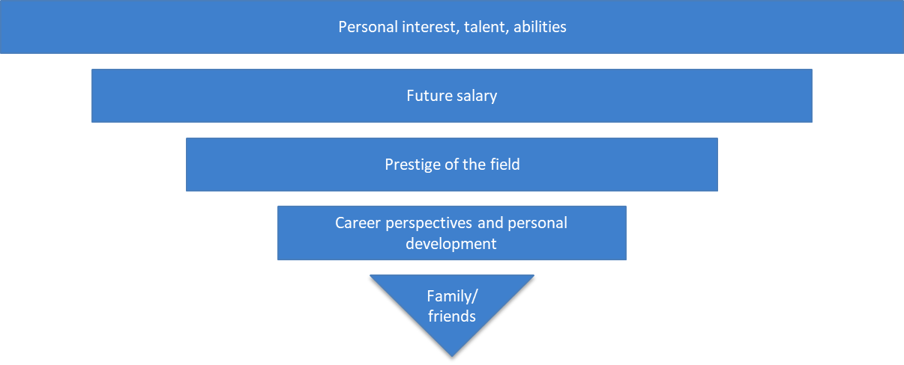
Picture 4: The relevance of the criteria on deciding future study field in Lithuania
Latvia | In Latvia, two categories of the influencing factors were named as having the most weight in determining the future study field of a student: Personal interest and being successful in specific fields and Approachability of the field; following the importance of the opportunities and possibilities the field provides as well as future salary and, lastly, how prestigious the field is (see the picture below).

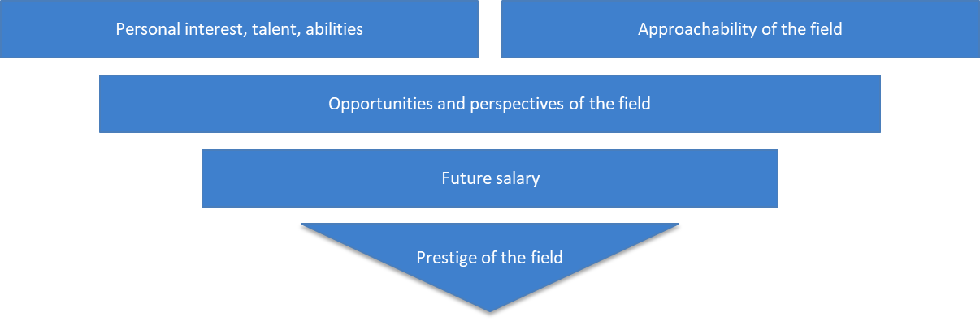
Picture 5: The relevance of the criteria on deciding future study field in Latvia
Estonia | In Estonia, the dominant responses were the aspects related with personal interests, abilities and talents of the student. The second equally accentuated aspects were future salary and approachability of the field. The influence of the parents and family were named afterwards. Even three responses were underlined as equally influencing the decision of the student: the teachers, friends of the student as well as the general demand of specific type or specialization specialists in the labour market. Lastly, the versatility and flexibility of the field itself was also seen as a strong influencer for a student (see the picture below).
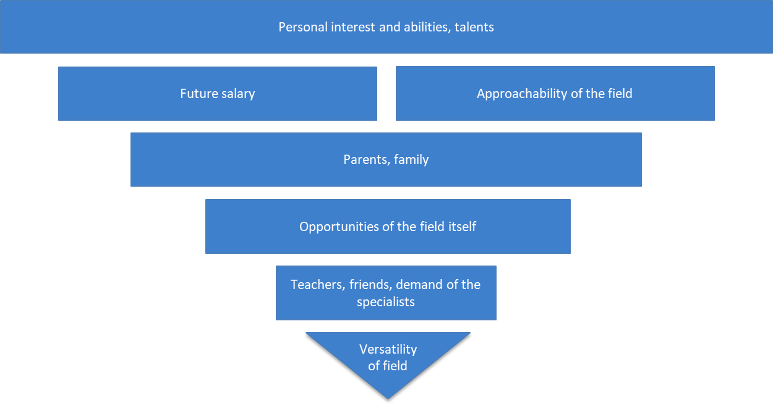
Picture 6: The relevance of the criteria on deciding future study field in Estonia

The guideline
Based on the information gathered during the study, guidelines have been developed that are recommended for use in the organization of career counselling activities in schools. The guidelines are intended for all career guidance counsellors working in schools with teachers who are covered by career guidance services, or teachers and professionals performing their duties. The aim of the guidelines is to help career guidance professionals and teachers working with young people in schools to contribute to the interests of students and to reduce the influence of external and internal factors in choosing a career path. In the context of the TInnGO project, special attention is paid to the tendency of girls to choose fields of higher education related to intelligent mobility and transport, STEM fields of science.
The guidelines are being prepared in the context of the TInnGO project, based on the objectives set for Baltic Hub in the Baltic Hub Action Plan set out in Objective 1: Improve women's motivation to work in the field of transport.
Despite the fact that the influence of teachers and counsellors on career choices was identified as minimal in the study of Baltic countries, the importance of these indirect factors cannot be underestimated. Teachers and career counsellors with authority in the eyes of students can play an important role as a listener or counsellor without directly influencing a particular student’s career choice.
The study of Idit Katz, Rinat Cohen, Moran Green-Cohen, Suzi Morsiano-davidpur has shown that the context surrounding a student’s career choices is critical to his or her final outcomes. In particular, that it is important for parents to create an environment that supports the independence and helps their children to make their own choices. This independent decision will be linked to the whole learning experience of the chosen subject, as well as to general well-being and grades. The results of the study emphasize that self-sustaining parenting is important in adolescence at a time when many issues of independence, identity, sexuality, and relationships are at stake, and is crucial when adolescents make their first career decision.
Often young people are impressed and can choose a career field that is popular, chosen by peers, or learned only from rumours. Teachers and career counsellors have the opportunity not to be too specific in the topic, but to help students understand their own desires, hobbies, or possibilities. Through interviews, counselling, or discussion, students are also introduced to potential future problems and challenges related to their careers, studies, or even work.
Despite that, given that students' career choices are strongly influenced by external factors, such as family members, career guidance should not be limited to students. Career counselling activities may also be relevant to students ’family members. The aim is for students not to be pressured by those around them about the career path they choose. The question of career is a particularly sensitive aspect, during which the student is obliged to assess himself / herself, his / her hobbies and abilities, to predict whether they will change in the long run, the current and future labour market, the relationship between the demand and supply of the profession. Thus, these and other aspects create a tremendous amount of pressure in the life of a young personality. In order to reduce it and not oblige the student to please and disappoint the parents in another respect, it is recommended to encourage family members to be tolerant of the young person's career choices. This can also be encouraged through separate communication with students ’parents. This can be organized through career-specific meetings or individual manifestations of distance communication, such as emails, memos, or educational videos.

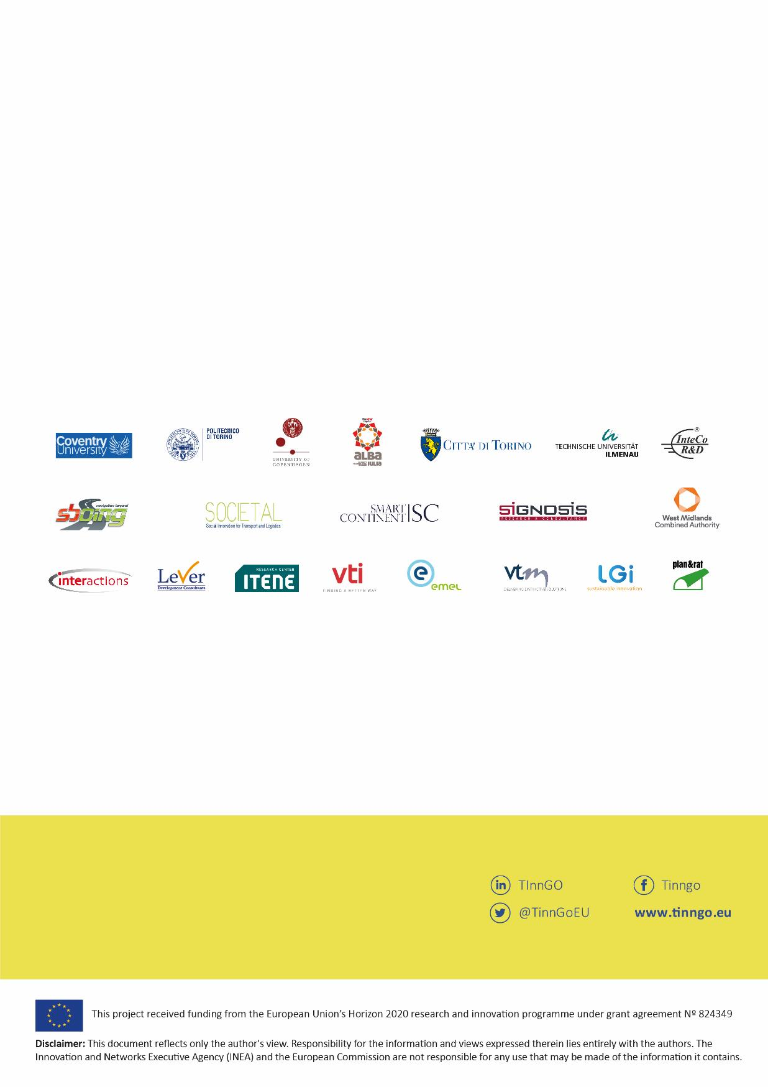
www.transportgenderobservatory.eu
Principal investigator
Andree Woodcock
adx974@coventry.ac.uk

@TinnGoEU
www.tinngo.eu
TInnGO
TInnGO
TInnGO
TInnGO is funded by the European Horizon 2020 program, and its objective is to promote gender equality and diversity in the transport sector in the European Union. The project, led by Coventry University, began in December 2018 and will run for three years.

Amoah, S. A., Kwofie, I., & Kwofie, F. A. A. (2015). The School Counsellor and Students' Career Choice in High School: The Assessor's Perspective in a Ghanaian Case. Journal of Education and Practice, 6(23), 57-65.
Amoah, S. A., Kwofie, I., & Kwofie, F. A. A. (2015). The School Counsellor and Students' Career Choice in High School: The Assessor's Perspective in a Ghanaian Case. Journal of Education and Practice, 6(23), 57-65.
Eliophotou Menon, Maria. (2010). The effect of career counsellors on the decision to pursue higher education: A mixed-methods investigation. Journal of Further and Higher Education. 34. 519-536. 10.1080/0309877X.2010.512079.
Euroguidance: https://www.euroguidance.eu/guidance-system-in-estonia#_ftn1
Euroguidance: https://www.euroguidance.eu/guidance-system-in-latvia
Euroguidance: https://www.euroguidance.eu/guidance-system-in-lithuania
Vocational Education and Training
Sharif, Nimra, Nawaz Ahmad, and SamiUllah Sarwar. "Factors influencing career choices." IBT Journal of Business Studies 15.1 (2019): 33-46. https://ibimapublishing.com/articles/JSAR/2017/718849/718849.pdf
Katz, Idit, et al. "Parental support for adolescents' autonomy while making a first career decision." Learning and Individual Differences 65 (2018): 12-19. https://www.sciencedirect.com/science/article/abs/pii/S1041608018300797

