Guidelines for education institutions no.1
Career counselling for school students

Deliverable fact sheet
Document name |  | Guidelines for education institutions No1:  Career counselling for school students
Responsible partner |  | Smart Continent
Authors |  | Egle Kalasnikovaite, Ieva Girdvainiene
Work package no. |  | WP3
Work package title |  | Management on Coordination of National HUBs
Dissemination level (please select one)
CO | Confidential, only for members of the consortium including the Commission Services
PU | Public |  | X
PP | Restricted to other programme participants, including the Commission Services
RE | Restricted to a group specified by the consortium including the Commission Services

Contents

The research 4
1. Career guidance in theory 4
2. Guidance practices in Baltic states 5
Guidance system in Estonia 5
Guidance system in Lithuania 6
3. Analysis of the data gathered and the guideline – age of the students 7
3.1 The study on career guidance 7
3.2 Consulting process and the age of the students to consult 8
3.3 The guideline 12

The research
The Baltic Hub conducted a study to identify the practical link between career counselling and how students choose higher education and post-graduate education, focusing on the areas of STEM, smart mobility and transport. Within the framework of this research, the analysis of the theoretical basis and legal framework, consultations with schools in the Baltic States and the analysis of the collected data took place. The aim of this work is to develop theoretical material that could be used in schools, career counselling and related institutions to encourage students not to be constrained by external factors in pursuing their career goals and to stimulate students' interest in STEM and smart mobility studies. The theoretical material consists of 3 subject oriented guidelines. In this document the subject of school student consultations and their type was set and discussed.

1. Career guidance in theory
Because of the importance of the school environment in the life of a student, it can seem that school experiences and imprint of a school environment have a mildly strong influence on a student when deciding his or her career preferences as well. In a 2013 study of S. A. Amoah, I. Kwofie and F. A. A. Kwofie “The School Counsellor and Students' Career Choice in High School: The Assessor's perspective in a Ghanaian Case“ , the impact of the school career counsellors was being analysed.
The authors have analysed qualitative and quantitative researches on the subject of whether and how the career counsellors play role in the students career preferences and decision. According to the results of their research, the impact of the career counsellors was defined as existent but had low significance. Authors say, this outcome might be impacted by the lack of resources of the counsellors, the absence of effective or efficient follow-up, etc. The authors of the article have recommended to apply frequent intervention programmes for students “in order for the to make well informed choices”.
Another analysis of Maria Eliophotou Menon on the students in Cyprus demonstrated that “career counsellors are of very little importance as sources of influence and guidance in the decision-making process preceding entry into higher education.” The authors have identified several aspects (mostly related to the workplace issues) that could influence such a minor impact of the career counsellors for the students regarding the career choice: the heavy workload and associated inability to advise effectively large numbers of students; the lack of clearly defined roles and responsibilities; their employment in more than one school unit; the lack of up-to-date information on career development choices and recent educational reforms; their limited communication and cooperation with external agents; and the lack of supporting mechanisms and appropriate infrastructure.

2. Guidance practices in Baltic states
In this chapter, the institutional and legal framework of career guidance and national practices will be presented.

Guidance system in Estonia
For some time now, lifelong vocational guidance has been practiced in Estonia, not limited to one age group, but promoting the development of the population's abilities according to their interests, hobbies and desires. During the development of these services, various service providers were responsible for their provision and implementation, but this is currently done by Career Services.
2020 A follow-up to the Estonian Lifelong Learning Strategy was prepared in 2021-2035. education strategy. The strategy sets out the main goals of education for the next 15 years. The overall goal of the strategy is to provide the Estonian population with knowledge, skills and attitudes that will prepare people to realize their potential in their personal, professional and social lives and to contribute to improving the quality of life in Estonia and global sustainable development.
Following the recognition by the Estonian government of the need to improve the availability and quality of career services, in 2018 The reform of service provision was launched in 2019. career counselling and career information services were launched. Responsibility for these areas fell on the public employment services under the Ministry of Social Affairs.
The role of general education, vocational training and higher education institutions in providing career guidance for pupils and students is to ensure that their pupils have access to lifelong guidance and to help them achieve the learning outcomes set out in their curricula.
Vocational guidance for students is provided and provided by the education system, integrating career education into programs at different levels of education and has a long tradition. In the education sector, career guidance activities are provided as part of youth work and formal education. General skills, including career management skills, are developed in pre-school education. Children begin to discover their education, get to know each other and understand the current profession of themselves and their surrounding parents, the concept of work and the labour market in general. Children are helped to develop general skills, such as cognitive and learning skills, social skills and self-management skills, which are essential for coping with education, the labour market and society in general. The development of such skills and competencies is supported throughout the study period at all levels of education.
Guidance system in Latvia
Under the supervision of the Ministry of Education and Science, schools have the main responsibility for student career guidance. From primary through upper-secondary education both general and vocational schools provide careers education. National education standards determine that one of the main goals of education is to prepare students to make a conscious career choice. Career management skills are integrated into subject standards as learning outcomes.
On 29 March 2006 the Cabinet of Ministers approved the White Paper “Improvement of the Career Development Support System”, providing that the career development support system (CDSS) consists of the three following basic elements:
- information,
- career education,
- career counselling.
The responsibility for the implementation of the CDSS is shared by the Ministry of Welfare and the Ministry of Education and Science. Both authorities are the key institutions that monitor the career guidance system in Latvia and guidance services provided in education institutions and employment offices.
The Ministry of Education and Science is responsible for the development and implementation of national education policy and coordinates the implementation of career education within the education sector as a whole. The State Education Development Agency subordinated to the Ministry of Education and Science is the main institution developing recommendations and tools for improving guidance in schools, including on-line information on education opportunities and the world of work, and career self-assessment tests.

Guidance system in Lithuania
The formation and development of the student career guidance system in Lithuania is the responsibility of the Ministry of Education, Science and Sport (career guidance policy related to the provision of quality career education, information, and counselling services for pupils, students, adult learners, etc.). In the education sector, career guidance (i.e. career education, information, and counselling services) is provided by general education schools and VET schools.
To ensure the accessibility of career information and counselling services, a special focus is put on career guidance information systems. In 2008, the Ministry of Education and Science developed a national database of learning opportunities titled AIKOS (Atviro informavimo, konsultavimo ir orientavimo sistema – Eng.: Open Information, Consultation and Orientation System), which makes data on education, statistics, and labour registers available to a wide range of customers and offers relevant information to career guidance service providers. Funding for career guidance services comes from diverse resources: the state budget, ESF funds, and funds from Active Labour Market Resources and the Youth Guarantee Initiative.

3. Analysis of the data gathered and the guideline – age of the students
This chapter briefly presents the completed study, highlighting a specific aspect – the age and related problematic and possibilities regarding the age of the students when being provided career counselling activities. This aspect is based on the lyrical material. Based on the analysis and literature, the identified topic provides a guide for research institutions to use when organizing career counselling activities.

The study on career guidance
The Baltic hub has contacted 30 schools in Estonia, Lavia and Lithuania by asking to participate in the consultations about the career consulting practices in the school, the general position towards career counselling and the perception of the students towards smart mobility and transport education. The schools were picked randomly but with a condition: the education in the school should be provided for senior students (those that are preparing for their school graduation). Before the discussions, it was emphasized that the possibility exists that the career counselling, if organized, could be performed in different ways in schools / countries (e.g. the activities are organized by different actors, consultations provided for specific group of students, etc.) and so the interlocutors representing the schools during the consultations should be aware of the organization process, context, outcomes, and processes of the career counselling of the students at respective school. In this way the information gathered from them would be as much accurate as possible. It is noted that in the context of TInnGO project, the specific link between career counselling and smart mobility and transport sector was set up during the consultations.
In further pats of this chapter, the research performed in the schools will be presented and outcomes regarding every country will be analysed.

Consulting process and the age of the students to consult
Career counselling activities in schools are usually directly related to when students begin to choose and narrow down the field of their academic subjects or when choosing which exams they would like to take when leaving school. However, it is important to emphasize that students until the upper grades take a general course with a couple of individual elective subjects. A few years before leaving school, students are required to narrow down the range of their academic subjects based on their pre-existing interests, hobbies or expectations, and to focus only on those that are most interesting / necessary to them and whose exams they have potentially will hold.
Although in theory such a mechanism should enable students to take an interest in and plan for future study and career prospects (and thus take advantage of career counselling opportunities) before taking the exam, in practice the processes take place somewhat differently. When enrolling in a desired higher education curriculum or institution, prospective students are usually selected by the institution on the basis of their learning outcomes - examination results (except in individual cases where students are admitted on the basis of an entrance examination). In order for prospective students to obtain the highest possible score during the exam, it is necessary to consistently prepare for the exam, to study (especially those academic subjects that are complex, interrelated and whose knowledge should be holistic, such as mathematics, physics). Following this logic, students should anticipate as early as possible what academic subjects they will delve into in order to avoid academic gaps. This means that even a few years before graduation, students are required to plan at least a preliminary path for their future academic activities.
Thus, the need for career counselling services does not necessarily arise only after graduation, when considering where and what program to study in higher education institutions, but this need may arise much earlier - when students are still choosing their academic preferences.
With this in mind, the Baltic hub has analysed a research of schools in the Baltic region when, according to them, students were becoming interested in career counselling opportunities.
Lithuania| 50 percent schools in Lithuania provide periodic consultations for all senior students. 12 percent of representatives in Lithuania said that career consultations are being performed only for those who apply for the consultations, another 12 percent told that consultations are being performed both, periodically for all the senior students and for those who apply, and another 12 percent told that the consultations are being performed for all students (gymnasiums) (see the picture below).

Picture 1. Consulting wchich students in Lithuania, perc.
Regarding the age of the students consulted, the opinion of Lithuanian respondents separated into almost equal parts after asking what is the age of the students that usually start consultations on the career subject. Equally –20 percent of the respondents told that usually students start consulting about career while being 16 and 17 years old. The others as well equally named the age of under 15, 15 and 18 years old. It means that the career consultants face the interest of the students towards career consulting at different ages. Mostly the students are getting inclined to the subject while being 16-17 years old. It is the time of choosing module lessons in senior grades in the school so the students are obliged to choose the directions of their future lessons which will as well correspond to their study field after graduation.

Picture 2. Age of the students seeking for consultations in Lithuania, perc.
Majority of representatives (76 perc.) have also stated that most often students apply for the career consultations in order to decide on their main study filed whereas 12 percent told that the students are mostly aware on the study field they would be interested in, but they feel the need to consult on specific related questions (the education institution, specific study program, etc.).
Latvia | As mentioned before, the schools in Latvia as well mostly consult the senior students (50 percent). 12,5 percent of Latvian respondents said that career consultations are being performed for those who apply. 12,5 percent told that consultations are being performed for all the students in the school and 12,5 percent told that both, periodic consultations for senior students and for those who apply are performed (see picture below).

Picture 4. Consulting which students in Latvia, perc.
Talking about the age of the students when they start their career consultations, most of the respondents (40 perc.) said that it was 15 years old followed by 16 years old (30 percent of the respondents).

Picture 3. Age of the students seeking for consultations in Latvia, perc.
The representatives form Latvian schools agreed (75 perc.) on the nature of the consultation – majority of the students usually seek for the consultations trying to decide on their main future study field. Whereas 25 perc. told that consultations mainly are dedicated for the students to get the insights on the specific topics on the study field that is already in their mind.
Estonia | Interestingly, even 36 perc. of Estonian schools replied that the consultations of the students are being organized only for those who apply for the consultation, whereas in Latvia and Lithuania the percentage of this option is relatively low. Another 9 percent told that the consultations are being performed for all the students.

Picture 6. Consulting the students in Estonia, perc.
As their colleagues form Latvia, majority of Estonian representatives (54,5 perc.) said that majority of school students begin consulting on the career was 15 years old, followed by 17 years old (27 percent).

Picture 5. Age of the students seeking for consultations in Estonia, perc.

In Estonia, as well as in other Baltic region countries the same tendency is noticed: 73 perc. of representatives agreed that most of the students apply for the consultations with an aim to decide on the general study direction that they would like to pursue in the future whereas 27 percent told that students are more interested in specific information about the career field they already know.
In general, most of the respondents from all three countries mentioned that the career counselling is usually being periodically performed mostly for senior students.

The guideline
When analysing the information, a significant negative aspect of career counselling in schools was noted, when career counselling is conducted by school staff. Occasionally, school staff may devote time to other activities, such as assisting a student with academic matters (counselling, explaining an incomprehensible topic, etc.), instead of carrying out career counselling work for students. Notwithstanding the benefits accruing to the student in accepting academic assistance, it must be acknowledged that the education of the student in career planning matters suffers. Carrying out career counselling in cooperation with external career counsellors would help to solve this problem. Through the school’s collaboration with external experts, students could gain the attention and expertise of completely impartial individuals who link their ongoing careers to a similar field that continually raises their expertise. With the participation of another party in the counselling process, abuse of career counselling time should be reduced.
Based on the analysis, it was found that the potentially low role of career counsellors in students' choice of profession is possibly related to the fact that students do not trust these people and take them lightly. In the late adolescence, students attach great importance to the opinions and choices of their peers. Thus, the involvement of experts in their field in the career counselling process and the use of counselling opportunities provided by them should increase the quality of career counselling activities. The study of Awinsong found that most students would like to discuss career choice decisions with counsellors. Although students do not consider counsellors to be the best knowledgeable and able to advise perfectly, communication with a counsellor is another important contact in addition to parents, with whom career issues can be discussed at a high level.
Regarding the career guidance in general, career guidance programs must have a strategy that has a significant impact on the target group, with different genders, academic achievement, study flow, and the socio-economic status of the family. Moreover, for counsellors to undertake a more active role in the provision of information and guidance to students, the following appear to be necessary: an increase in the number of counsellors at schools; a job description which clearly specifies duties and responsibilities; additional training and support measures; and the improvement of facilities. Thus, there is a need to identify and resolve workload and job design issues at the workplace. In addition, professional development and in-service training programmes may also be necessary in order to provide greater support to career counsellors and enhance their effectiveness.
Another study of school students and high school students found that a young person recognizes the need for career counselling too late when a career path has already been chosen. Based on that, It is recommended to begin career counselling activities or at least inform the students on the possibility of career counselling in the earliest stage as possible. Students should be aware that they have a legal right to gain assistance in their professional and career development. Moreover, the career counselling activities should be scheduled and regular in order to make a firm and consistent preparation for the upcoming self-determination.

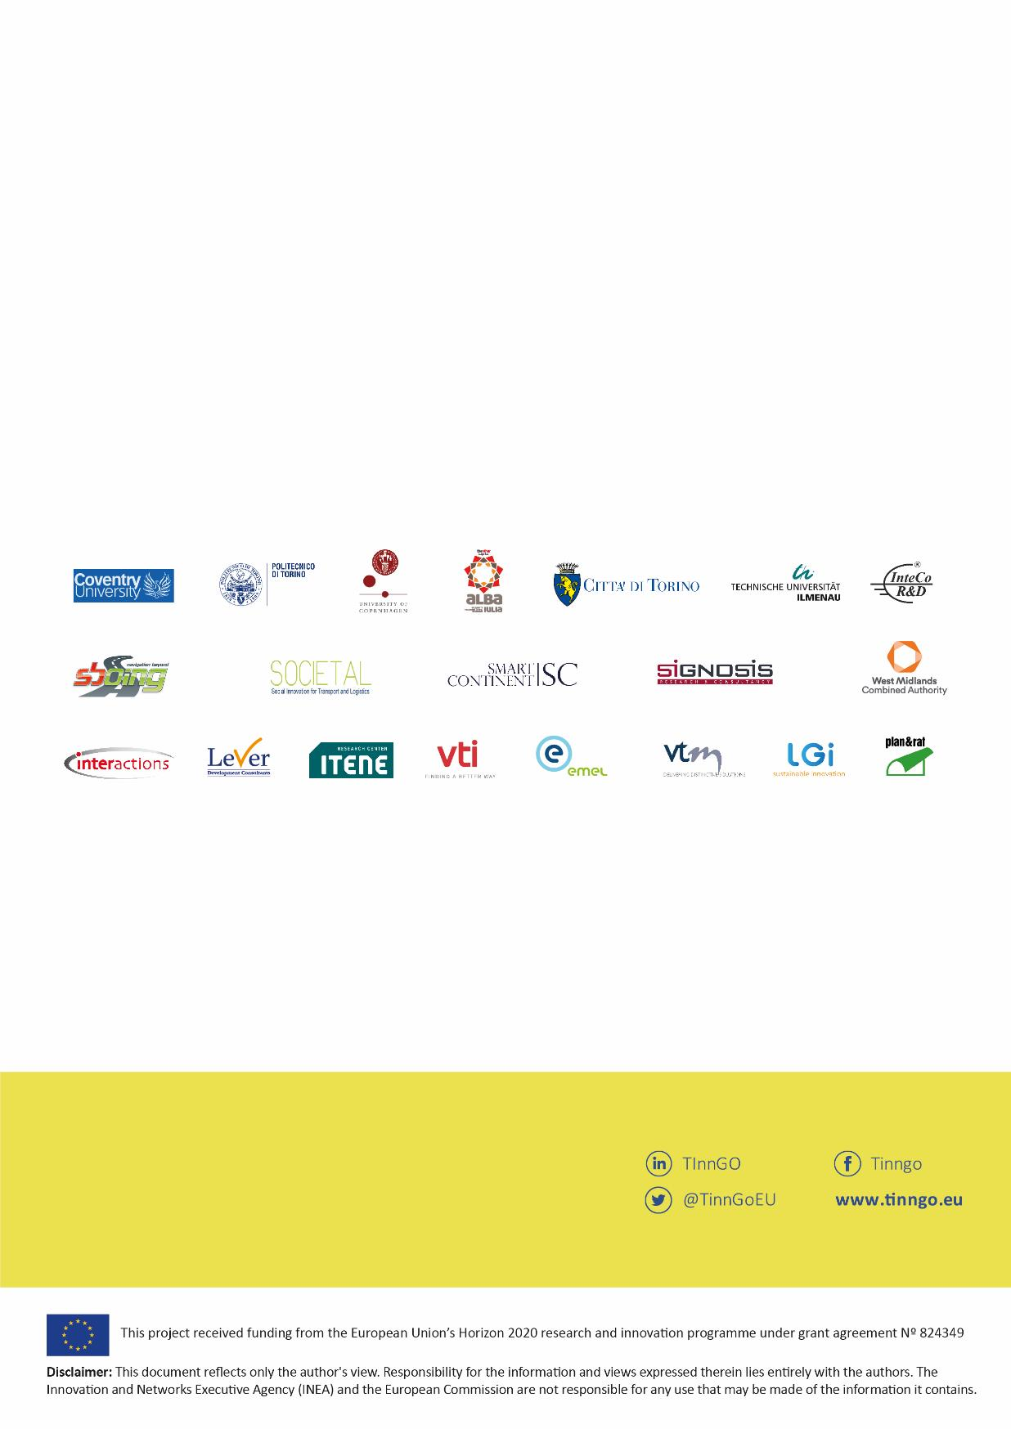
www.transportgenderobservatory.eu
Principal investigator
Andree Woodcock
adx974@coventry.ac.uk

@TinnGoEU
www.tinngo.eu
TInnGO
TInnGO
TInnGO
TInnGO is funded by the European Horizon 2020 program, and its objective is to promote gender equality and diversity in the transport sector in the European Union. The project, led by Coventry University, began in December 2018 and will run for three years.

Amoah, S. A., Kwofie, I., & Kwofie, F. A. A. (2015). The School Counsellor and Students' Career Choice in High School: The Assessor's Perspective in a Ghanaian Case. Journal of Education and Practice, 6(23), 57-65.
Amoah, S. A., Kwofie, I., & Kwofie, F. A. A. (2015). The School Counsellor and Students' Career Choice in High School: The Assessor's Perspective in a Ghanaian Case. Journal of Education and Practice, 6(23), 57-65.
Eliophotou Menon, Maria. (2010). The effect of career counsellors on the decision to pursue higher education: A mixed-methods investigation. Journal of Further and Higher Education. 34. 519-536. 10.1080/0309877X.2010.512079.
Euroguidance: https://www.euroguidance.eu/guidance-system-in-estonia#_ftn1
Euroguidance: https://www.euroguidance.eu/guidance-system-in-latvia
Euroguidance: https://www.euroguidance.eu/guidance-system-in-lithuania
Vocational Education and Training
Awinsong, Moses & Dawson, Omar & Gidiglo, Belinda. (2015). Students " Perception of the Role of Counsellors in the Choice of a Career: a study of the Mfantseman Municipality in Ghana. International Journal of Teaching, Learning and Educational Research. 13. 79-99.
Ismail, M. S., Abdullah, S. S., Mohamad, M. Z., & Khairuldin, W. M. K. F. W. (2018). Student’s Career Maturity: Implications on Career Counselling. International Journal of Academic Research in Business and Social Sciences, 8(4), 887–897, https://www.researchgate.net/profile/Zaidin-Mohamad/publication/325119739_Student's_Career_Maturity_Implications_on_Career_Counselling/links/5af94e27a6fdcc0c03345386/Students-Career-Maturity-Implications-on-Career-Counselling.pdf
Eliophotou Menon, Maria. (2010). The effect of career counsellors on the decision to pursue higher education: A mixed-methods investigation. Journal of Further and Higher Education. 34. 519-536. 10.1080/0309877X.2010.512079.
Cojocariu, Venera-Mihaela and Irina-Venera Cojocariu. “A Study on Raising Awareness of the Students’ Needs of Career Counselling☆.” Procedia - Social and Behavioral Sciences 180 (2015): 1058-1066.

